KIBAKWE SECONDARY SCHOOL
HOLIDAY PACKAGE

031 PHYSICS FORM FOUR
By MUSSA MJWANGA

- Where necessary the following constants may be used.
-Acceleration due to gravity = 10m/s²
-density of water = 1g/cm³ or 1000kg/m³
-Pie, $π=3.14$
-Non-programmable calculator (scientific calculator) and mathematical tables can be used.

- Write a letter of the most correct answer in the box provided for each of the following items
- When released from a height a ball falls 5m in 1 second. In 4 second from release it falls-
- 400m
- 100m
- 80m
- 40m
- 20m
- The pairs of physical quantities having the same S.I. unit are;-
- Mass and weight
- Velocity and speed
- Impulse and momentum
- Energy and power
- Force and power
- The angle between incident ray and reflected ray is 60⁰ in a plane mirror . The incident angle will be-
- 120⁰
- 60⁰
- 15⁰
- 30⁰
- 45⁰
- A wheel and axle of efficiency 75% is reduced to raise a load of 15kg . If the radius of the wheel is 40cm and that the axle is 4cm , then the effort required to overcome the load is-
- 10N
- 20N
- 200N
- 100N
- 250N
- Which of the following is a non renewable source of energy-
- Wave energy
- Radiant energy
- Bio fuels
- Fossils fuels
- Electric energy
- Colours are produced when white light passes through a glass prism because-
- The light wave interfere
- The glass colours the light
- Different colours travels at different speed
- The different colours are filtered
- Diffraction of light occurs.
- A wire X is half the diameterand half the length of the wire Y of similar material . The resistance of X to that of Y is-
- 8:1
- 4:1
- 2:1
- 1:1
- 1:4
- The lactometer is used to check purity of;
- Milk
- Sea water
- Mercury
- Gold
- Petrol
- A bucket is filled with equal amount of hot water and cold water the hot water is at 70c⁰ and the cold water is at 10c⁰ .The temperature of the mixture will be approximately
- 20c⁰
- 30c⁰
- 40c⁰
- 50c⁰
- 50c⁰
- Which of thefollowing can NOT be explained by the movement of molecules
- Expansion
- Conduction
- Convection
- Radiation
- Evaporation
- Match the items in List A with the responses in List B by writing the letter of the correct responses beside the item number

LIST A | LIST B
i.charles law  ii.pressure law  iii.boyles law  iv.general gas equation  v.lower fixed point | A.p1/t1=p1/t2  B. 280K  C.$∝=∆L/T1∆T$  D.V1/T1=V2/T2  E.212F  F.P1V1=P2V2  G. Joule  H. P1T1/V1=P2T2/V2  I.273K  J. 0K  K.V1/P1=V2/P2  L.Kelvin  M.$∝=∆L/L1∆T$  N. P1V1/T1=P2V2/T2  O. 0 C⁰  P. -273K

- For each of items (i)- (ii)complete the statement by filling in blank spaces by writing the correct answer in the booklet provided
- ………………is the ability of the eye lens to focus points at different distances
- Chemicals which can catch fire easily are called-------
- The molecules of glass and glass will attract each other by a force known as …………
- The gradual change of state from liquid to gas that occurs at the surface of liquid is called………………….
- The presence of electric charge in a body can be detected by means of………………
- State of balance of a body is called………………….
- The movement of liquid from law concentration to high concentration through a semi permeable membrane is called…………………….
- The length between two points in specific direction is called…………………..
- A type of reflection of light which occurs on rough surface is known as…….
- A substance that reduces the surface tension of a liquid is called ……
- a. i)What is buoyant force?
ii)Explain why dead bodies always float on the surface of water , but the head stays under water?
b.State the law of floatation
c. Asolid of area of cross-section 0.004m² and length 0.6m is completely immersed in water of density 1000kg/m³ and density of solid 7200kg/m³, Calculate
i. weight of solid in S.I.unit
ii. apparent weight of solid in water
- a. Define the following terms
i.Relative humidity
ii. Saturated vapour pressure
iii. Dew point
b.Explain the importance of controlling humidity as it is important factor in some case in a certain manufactruring and transporting purpose (at least two points)
c. Dry steam is passed into a well lagged copper can of mass 250kg containing 400g of water and 50g of ice at 0C⁰ .The mixture is well stirred and the steam supply cut off when the temperature of can and its contents reached 20C⁰ .Neglecting heat losses , find the mass of steam condensed.
Specific heat capacity of copper =0.4J/g
Specific latent heat of steam= 2260J/g
Specific latent heat of ice= 336J/g

- a. What do you understand by the term “lost volts” in the circuit shown
r=4Ω E=12V

4Ω 6Ω

40Ω
Calculate: i.the current drawn from the cell
ii.the lost voltage in the cell
iii.the potential difference across the 6Ω
b. i. Define the term lightning and lightning conductor and explain why lightning conductor terminates with sharp spikes.
ii.Define the term electric field lines as used in electrostatics.
- a. Define the following terms:
i.coefficient of linear expansivity
ii.coefficient of cubic expansivity
b.Part of a steel tap used by a surveyor is 20m at 12⁰C .What is the overall length measured by using this part of the tap one hundred times on a warmer day corresponding to 22⁰C?
linear expansivity of a steel = 11x10⁻⁶/k
c. Explain why the cooling unit (freezer) inside a refrigerator is placed near the top but an electric immersion heater in a water tank should be near the bottom.
- a. What do you understand about the following terms
i.limiting friction ii.coefficient of friction
b. A 4kg brick is at rest on a table . It requires a force of 16N to start the brick sliding. A 2kg mass is placed on top of the brick. What force will be required to start sliding?

- a. Differentiate between reflection and refraction
b. i. state the laws of refraction of light
ii. calculate the critical angle (C) for air-glass medium if the refractive index of glass is 1.52
c. i. Draw the pattern produced when white light is dispersed using a triangular glass prism.
ii. A flag has a green disc on a yellow background . How will the flag appears in
- green light b. red light c. blue light
- a. What is meant by magnetic materials?, give two examples
b. State the law of magnets
c.Explain with an illustration how one can locate the position of a North –pole of a bar magnet.
d. Explain with an illustration how to magnetize a steel bar using an electric current.

- a. Using Newton’s second law of motion , state two quantities which vary with net force applied on a body.
b.Write an equation obtained by combining the force and the two quantitiesyou have mentioned.
c.Evaluate the proportionality constant , if your equation is used to define the unit of force , the Newton while taking a unit of each variable in your equation
d.A certain force gives a mass m1, an acceleration of 12m/s² . What acceleration will the same force give two similar masses when they are joined together?
- Choose the correct answer and write the letter beside the item number
- The attractive force between molecules of different substances is called
- magnetism b. cohesion d. adhesion e. capillary
- which of the following words would not look identical to their mirror image?
a.MOM b.HAT c. TOT d. DAD
- If you are 180cm away from a mirror what will be the position of your image ?
a.180cm in front b. 360cm behind c. 360cm infront d. 180cm behind
- If you are caught outside during severe thunderstorm , you shoud……
- Take shelter under the nearest tree b. stand under electric power line c. move to a higher ground d. hide in a ditch (ground hole)
- The SI unit of capacitance is………………
- Farads b. joules seconds c. volts d. coulombs
- The current travelling through the filament of a lamp is 2A . How many electrons pass through the filament in one second?.............
- 20A b. 2C c.2V d.4C
- Large amount of electricity is measured by using……….
- Galvanomter b.Ammeter c. Voltmeter d. Thermometer.
- Pressure in liquids depends on the ………………..
- Density of the mercury b. depth of the liquid c. density of water d. height of the water
- The following is the reason of why objects in the air tend to fall at the same time.
a.They have the same weight b. There is usually no resistance in the air c. Acceleration due to gravity is tha same d. Non of the above
x. The difference between the upper fixed point and the lower fixed point of a thermometer is called
a. fundamental interval b. fundamental quantity
c. fundamental force d. fundamental units

- Match each item in List A with an item in list B
LIST A | LIST B
a.light | i.flat nsurface
b.plane mirror | ii.laminous
c.umbra | iii.translucent
d.semi-transparent | iv.periscope
e.right angle mirror | v.partial shadow
f.diffuse | vi.non luminous
g.used in submarine | vii.3x10⁸m/s
h.eyes see image due to | viii.full or total shadow
i.bulb | ix.repel each other
j.like charges | x.inverted images
 | xi.images are three
 | xii.telescope
 | xiii.reflection of light
 | xiv.attract each other
 | Xvupright images
 | xvi.images are infinite
- Complete each of the following statements by writing the correct answer in the space provided
- If the temperature of the conductor was increased , its resistance would……………
- Resistance of an electric current is measured in units called …..
- A glass rod rubbed with …..becomes….charged
- An ……eod rubbed with ….becomes negatively charged
- The ratio of mass of an object and its volume is called……..
- Differentiate between the following
- A vernier caliper and micrometer screw gauge
- Resistance and capacitance
- Static electricity and current electricity
- Pressure and force
- Eleastic materials and plastic materials

- a. Define the term pressure
b.show that the pressure in liquid is given by ƍgh
c. An object weighs 200N on the earth. What would be its mass on the moon?
- a. Write the symbols of the following:-
- wire joining ii. capacitor iii.variable resistor iv. Ammeter
- Mention three functions of gold leaf electroscope
- Explain two characteristics for resistors connected in parallel.
- a. List four (4) transport vessels which applies the laws of Physics.
b.Why is it important for all apparatus used in electrical experiment to be thoroughly dried?
c. List down three sources of electrical energy.

- a. i. What is the capacitor? ii.A capacitor of capacitance 200µF is allowed to charge. The P.d between its plates is 10V . How much charge will accumulate on the plates during the period of charging?
- Mention three methods used to charge a body.
- a. What is the uses of the following
i. barometer ii. Capacitor iii. Manometer iv. U-tube
b. consider the figure below

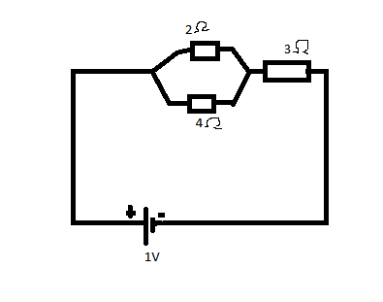
From the figure above , calculate
- Total resistance ii. total current flowing
- a. Mention three uses of current electricity
b. Why is it advised to connect bulbs in parallel arrangement during installation of electricity in most buildings? (two points).
c. Form two student at Kibakwe secondary school who were conducting an experiment
to verify Ohm’s law in the laboratory were given the following instructions:-
Connect in series a resistor R, a battery B of two cells , a switch K , an ammeter A and rheostat S .Then connect the a voltmeter V across the resistor . Draw a well labeled circuit representing this experiment.

Data needed to answer questions can be found in the Data, formulae and relationships sheet.
- A ball is thrown vertically upwards. It rises to a maximum height X where it is momentarily at rest. It then falls downwards.
Which statement is true about the ball’s acceleration? [1]
A The acceleration of the ball is always in the same direction as its velocity.
B The acceleration of the ball is always in the opposite direction to its velocity.
C The acceleration of the ball is downwards at all points including X.
D The acceleration of the ball is zero at X.
24. A landing module is falling towards the Moon’s surface at a steady speed of 5.00 m s⁻¹. At a height of 62.5 m, a small object becomes detached from the landing module and accelerates
down with the acceleration of free fall on the Moon 1.60 m s⁻². At what speed does the object
hit the Moon? [1]
A 14.1 m s⁻¹
B 15.0 m s⁻¹
C 200 m s⁻¹
D 225 m s⁻¹
25. A ball is dropped vertically from rest at time t = 0 and accelerates downwards with an acceleration g.
t = 0
t = t₁
t = t₂
distance
What distance does it travel between t = t₁ and t = t₂? [1]
A gt₂²
B g (t₁ + t₂)
C g (t₂ − t₁)²
D g (t₂² − t₁²)
26. The velocity–time graph is for a stone thrown vertically upwards.
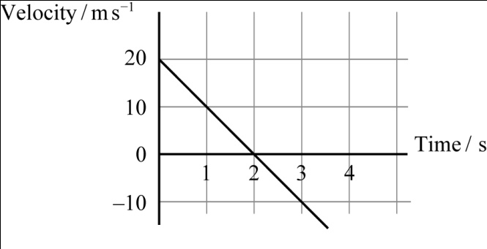
When time t = 3 s, what is the displacement of the stone from its starting position? [1]

A 5 m
B 15 m
C 20 m
D 45 m

27. Ball X is projected horizontally at the same time as ball Y, of twice the mass, is released from
rest. Both balls fall vertically from the same height and hit the horizontal floor below. Air resistance is negligible. Which statement is true? [1]
A Y will hit the floor just before X.
B X will hit the floor just before Y.
C X and Y will hit the floor at the same time.
D Y hits the floor while X is half way to the floor.
6 Define acceleration and state whether it is a scalar or a vector. [2]
7 A footballer kicks a ball from rest. The foot is in contact with the ball for 0.30 s and the final velocity of the ball is 15 m s⁻¹. What is the average acceleration of the ball? [3]
8 The diagram shows the velocity–time graph for an object.
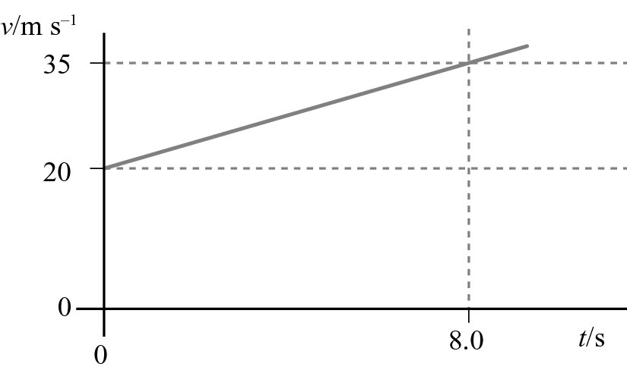
a Describe the motion of the object. [1]
b Calculate the acceleration of the object. [3]
c Use the graph to determine the distance travelled by the object in 8.0 s. [3]
28. A car slows down from a velocity of 22 m s⁻¹ to 5.0 m s⁻¹ in a period of 6.0 s.
For this car, calculate:
a its deceleration [3]
b its average velocity [1]
c the distance travelled in 6.0 s. [2]
29. A painter accidentally drops a can of paint from a bridge over a river. The can is in free fall
for a time of 2.3 s before it hits the water below. The acceleration of free fall is 9.81 m s⁻².
a Calculate the velocity of the can just before it hits the water. [3]
b What is the height of the bridge? [3]
30. A cyclist is travelling at a constant velocity of 4.0 m s⁻¹. She suddenly accelerates at 0.45 m s⁻² for a distance of 9.0 m. Calculate her final velocity. [3]
40. A racing car travelling at a velocity of 45 m s⁻¹ hits a safety barrier. The car comes to a halt
after travelling a distance of 20 m. Calculate the average deceleration of the car. [3]
41. An object has a uniform acceleration a. After a time t its final velocity is v.
a Sketch a graph of velocity against time for this object. [2]
b Show that the displacement of the object in this time is given by:
[4]

42. A metal ball is dropped from a height of 6.0 m onto soft ground. The ball hits the ground and penetrates a distance of 8.5 cm. Calculate the deceleration of the ball as it enters the ground.
You may assume that the ball decelerates uniformly. (Acceleration of free fall = 9.81 m s⁻².) [5]
43. 1 The diagram shows a graph of the displacement of a wave.
What property of the wave is X? [1]
Displacement X
Time
A amplitude
B frequency
C period
D wavelength
44. The graph shows the displacement of particles in a sound wave. Which distance, on the graph, represents the amplitude of the wave?
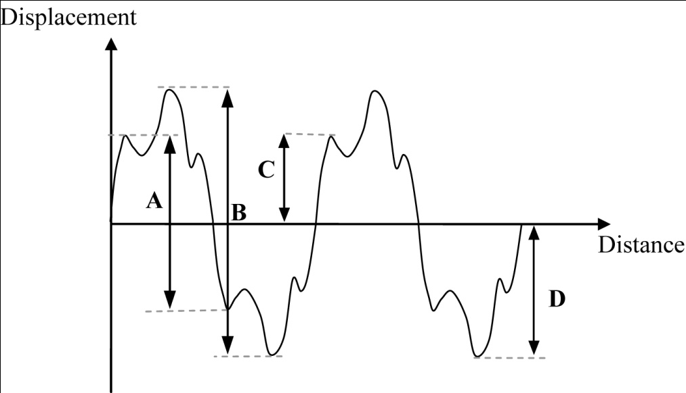 [1]
45. Which of the following cannot be polarised? [1]
A infrared waves
B microwaves
C sound waves
D ultraviolet waves
46. Red light has a wavelength of 684 nm. What is its frequency? [1]
A 2.05 × 10² Hz
B 4.39 × 10⁵ Hz
C 4.39 × 10¹⁴ Hz
D 2.05 × 10²⁰ Hz
47. An oscilloscope is connected to a microphone. The diagram shows the trace displayed when a note is played.
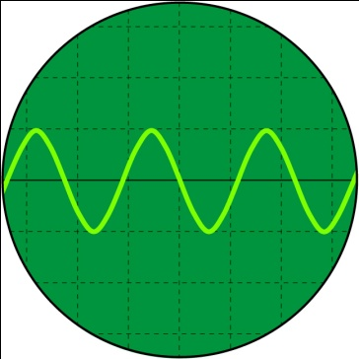
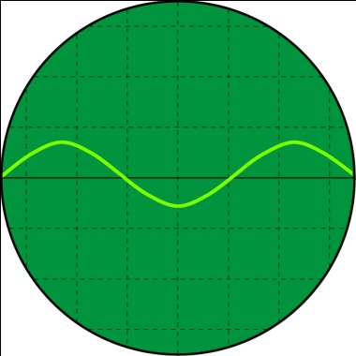
A note is played of half the amplitude and twice the frequency. The settings of the oscilloscope remain unchanged. Which diagram shows the trace for this note? [1]
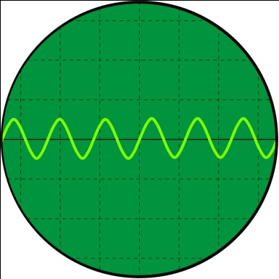
B
A
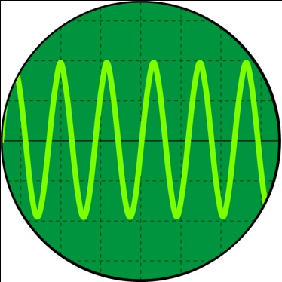
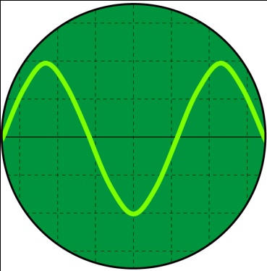
D
C
48. Calculate the frequency of the following waves:
a red light of wavelength 6.5 × 10⁻⁷ m emitted from a light-emitting diode [2]
b ultrasound of wavelength 7.0 mm emitted by a bat. [2]
49. In a water tank, a dipper oscillating at a frequency of 30 Hz produces surface water waves of wavelength 2.5 cm.
a Calculate the speed of the water waves. [2]
b Determine the wavelength of the waves when the frequency of the dipper is doubled. [2]
50. The graph shows the displacement of particles in a sound wave.
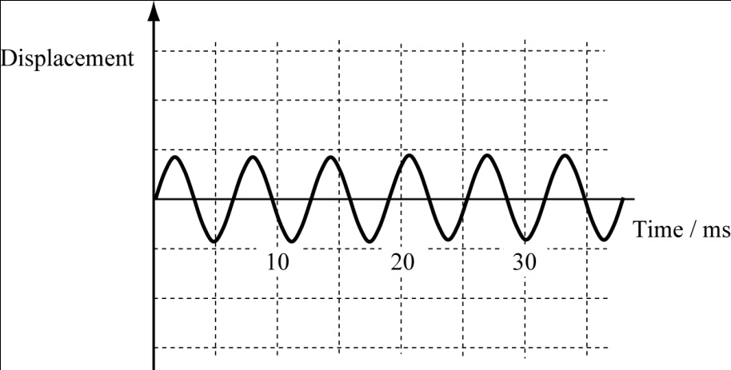
a Calculate:
i the period of the wave [2]
ii the frequency of the wave. [1]
b On a copy of the diagram draw a wave of the same frequency but four times the intensity. [1]
51. An oscilloscope has its time-base and Y-sensitivity (Y-gain) set on 0.5 ms cm⁻¹ and 0.5 V cm⁻¹, respectively. A person whistles into a microphone connected to the oscilloscope. The trace displayed on the oscilloscope screen is shown below.
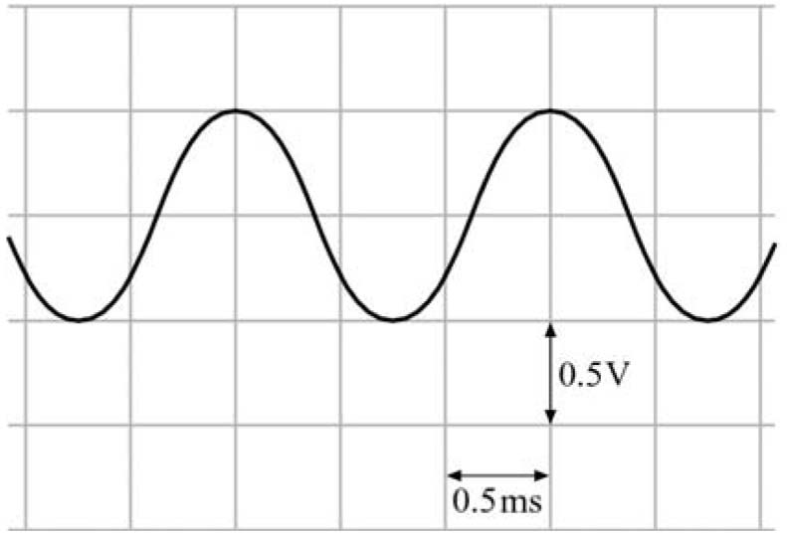
a Determine the frequency of the sound wave. [2]
b Calculate the wavelength of the sound produced by the whistle. [2]
52. You can use the following equation to determine the intensity of a wave:
This equation can be applied to all waves, including sound.
The intensity of sound at a certain distance from a loudspeaker is 3.5 × 10⁻³ W m⁻².
The amplitude of the sound waves at this point is known to be 0.45 mm. Calculate:
a the power transmitted through a cross-sectional area of 8.0 × 10⁻⁵ m² when the intensity
of sound is 3.5 × 10⁻³ W m^{–2} [2]
b the intensity of sound where the amplitude is 0.90 mm [3]
c the amplitude of the sound waves where the intensity is 5.6 × 10⁻² W m⁻². [3]
53. The intensity of a wave may be defined as the power transmitted per unit cross-sectional area at right angles to the direction of travel.
a For a point source of light, explain why the intensity I at a distance r away from the source obeys an inverse square law with distance, that is:
. [3]
b The intensity of visible light from the Sun reaching the upper parts of our atmosphere is
about 1.4 kW m⁻². The Sun has a radius of 7.0 × 10⁸ m and is 1.5 × 10¹¹ m from the Earth.
Calculate:
i the intensity of visible light emitted from the Sun’s surface [3]
ii the total power radiated by the Sun in the visible region of the electromagnetic
spectrum [2]
iii the intensity of light from the Sun at the planet Neptune.
(Neptune is 4.5 × 10¹² m from the Sun.) [3]

54. The graph shows the variation with time t of the velocity v of a car travelling along a straight road.
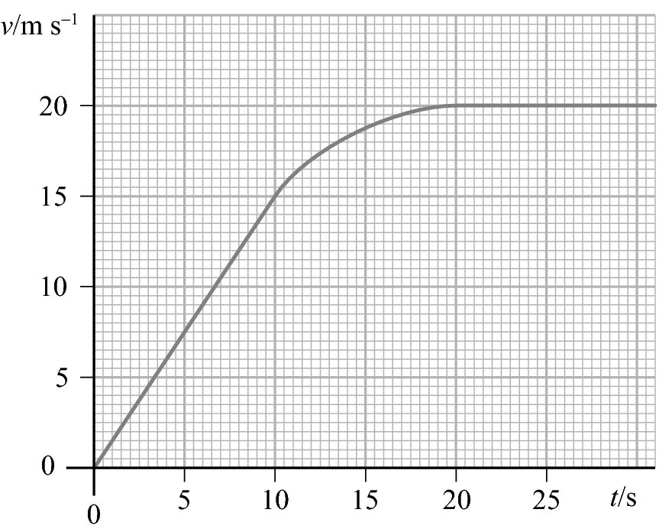
a Calculate the distance travelled by the car between 4.0 s and 8.0 s. [2]
b Calculate the acceleration of the car at 12.5 s. [3]
c Sketch a graph of acceleration against time for the car. [2]
55. A ball is kicked towards goal posts from a position 20 m from and directly in front of the posts. The ball takes 0.60 s from the time it is kicked to pass over the cross-bar, 2.5 m above the ground. The ball is at its maximum height as it passes over the cross-bar. You may ignore air resistance.
a Calculate the ball’s horizontal component of velocity. [1]
b Calculate the vertical component of the velocity of the ball immediately after it is kicked. [2]
c Determine the magnitude of the initial velocity of the ball immediately after it is kicked. [2]
d Determine the angle above the horizontal at which the ball is kicked. [2]

56. The diagram shows water waves passing through a gap.
What property of waves is being demonstrated? [1]
A diffraction
B interference
C superposition
D polarisation
57. The diagram show two loudspeakers connected to the same signal generator.
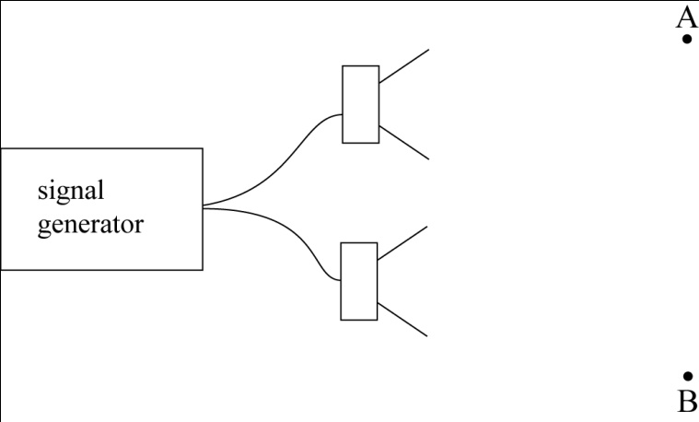
A girl walks from position A to position B.
Which statement describes what she will hear and gives the correct reason? [1]
A A rise and fall in the loudness as the waves go in and out of phase.
B A rise and fall in the pitch as the waves go in and out of phase.
C A steady loud sound because the waves are in phase.
D A steady soft sound because the waves are out of phase.
58. The graph shows two waves.
Which statement is correct? [1]
Displacement
Time
A The waves are coherent and in phase.
B The waves are coherent but out of phase.
C The waves are incoherent and out phase.
D The waves are incoherent but in phase.
59. A student sets up a experiment to show interference of light. He uses two small red LEDs as the light sources.
Which of the following explains why he will not be able to show interference? [1]
A The light from an LED does not does not have a single wavelength.
B The light from an LED does not have a constant frequency and so will not be in phase.
C The light from the two LEDs will not be in phase.
D The light from the two LEDs will not be coherent.
60. An experiment is set up to demonstrate interference from different types of electromagnetic radiation. The apparatus is shown below and the dimensions are kept constant for all types of radiation.
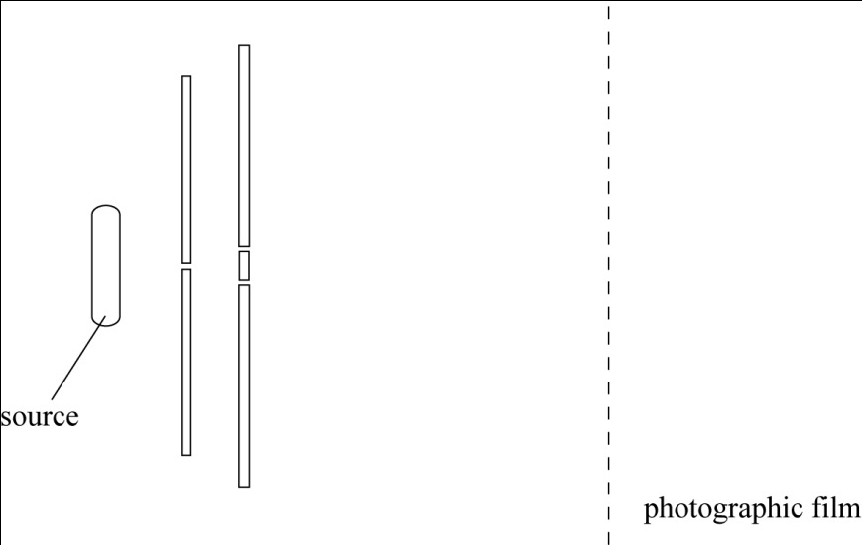
Which type of radiation will produce fringes which are the closest together? [1]
A blue light
B infrared radiation
C red light
D ultraviolet radiation
61. a Describe what is meant by the diffraction of a wave. [1]
b Electromagnetic radiation of frequency 7.5 × 10⁹ Hz is directed towards a slit
of width 6.0 cm.
i Determine the wavelength of the radiation. [2]
ii Explain whether or not the radiation will be diffracted at the slit. [1]
62. Explain what is meant by coherent sources. [1]
63. The diagram below shows the displacement–time graphs for two waves A and B.
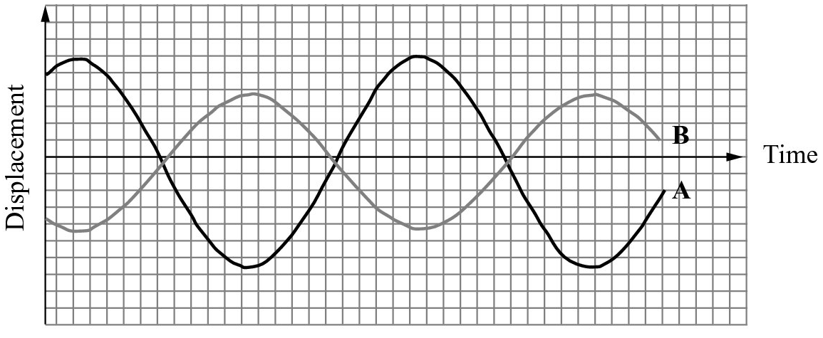
a What is the phase difference between the two waves? [1]
b The two waves A and B are combined. Name the type of interference that will occur. [1]
64. Which of the statements about stationary waves is true? [1]
A A node occurs where the vibration is at a maximum.
B An antinode occurs where the vibration is at a maximum.
C The distance between consecutive antinodes is one wavelength.
D The distance between consecutive nodes is one wavelength.
65. The diagram shows the fundamental mode of vibration on a string. The string is vibrating with a frequency of 60 Hz.
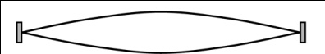
Which diagram shows the second harmonic, with the correct frequency of vibration? [1]
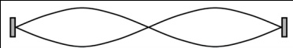
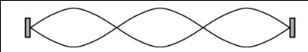
B
A
frequency = 120 Hz
frequency = 30 Hz
D
C
frequency = 180 Hz
frequency = 20 Hz

66. The diagram shows the apparatus used to measure the wavelength of microwaves.
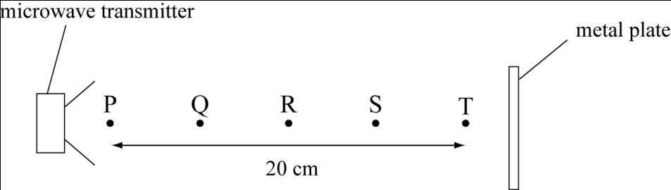
As a detector is moved from the transmitter to the metal plate, maxima are found at points
P, Q, R, S and T. What is the wavelength of the microwaves? [1]
A 4 cm
B 5 cm
C 10 cm
D 40 cm
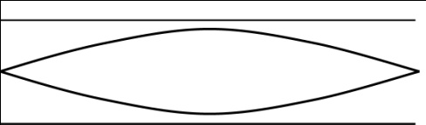
67. Which diagram shows the fundamental mode of vibration in an open pipe? [1]
A
B
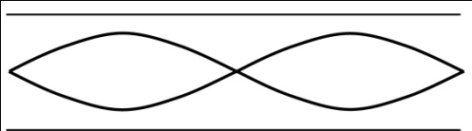
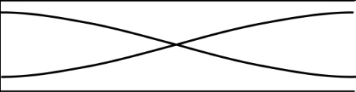

C
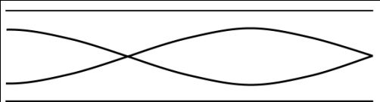
D

68. A vibrating tuning fork, held above a tube, sets up a standing wave in the air in the tube.
Which of the following statements is correct? [1]
A At the antinodes the particles vibrate back and forth, parallel to the length of the tube.
B At the antinodes the particles vibrate from side to side, perpendicular to the length of the tube.
C At the nodes the particles vibrate back and forth, parallel to the length of the tube.
D At the nodes the particles vibrate from side to side, perpendicular to the length of the tube.
69. One end of a rope is fixed and the other end is shaken rhythmically. A stationary (standing)
wave is formed on the rope. Explain how such a wave is formed on the rope. [2]
70. The diagram shows a stationary wave on a string.
75 cm
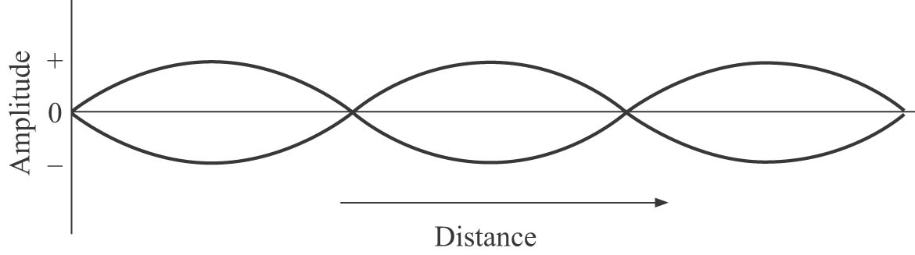
a Mark the positions of the nodes (N) and the antinodes (A). [2]
b Explain what is meant by a node and an antinode. [2]
c Determine the wavelength of the progressive waves on the string. [2]
71. A string of length 80 cm is fixed at both ends. The middle of the string is plucked. This creates
a stationary wave pattern on the string with one complete ‘loop’. The string is vibrating in fundamental mode with a frequency of 20 Hz. Calculate:
a the wavelength of the progressive wave on the string [2]
b the speed of the progressive wave on the string. [3]
72. A tuning fork vibrating at a frequency of 490 Hz is held above the open end of an empty bottle. When the length of the air column within the bottle is 17 cm, a fundamental mode of vibration
is set up in the air within the bottle and a loud sound is heard.
a Sketch a diagram of the stationary wave pattern. (Assume the air within the bottle is a
uniform cylinder of air.) [2]
b Determine the wavelength of the sound waves. [2]
c Hence determine the speed of sound in air. [3]
73. A string of length 1.6 m is held under tension. When the string is made to vibrate at a frequency
of 400 Hz, three antinodes are formed along this length of the string. Determine the speed of the progressive waves that form the stationary wave pattern. [5]
74. The diagram below shows a stationary wave pattern formed in the air between the open ends
of a tube when a vibrating loudspeaker is held at one end. The positions of the nodes (N) and antinodes (A) are also shown.
The length L of the tube is 60 cm. The speed of sound is 340 m s⁻¹.
Determine the frequency of sound from the loudspeaker. [5]
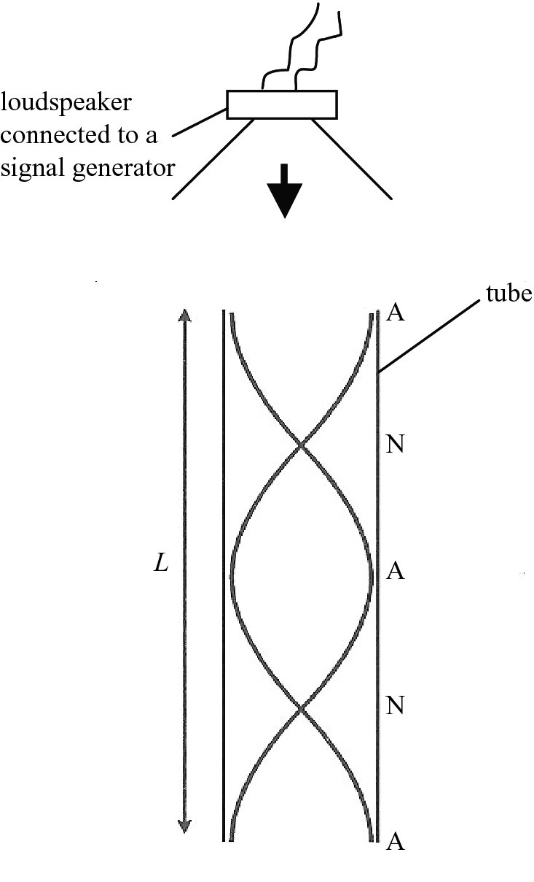
75. The nuclide decays by emitting α-particles and β-particles in a series of decays to form Pb. Eight α-particles are emitted in the sequence. How many β-particles are emitted? [1]
A 6
B 8
C 10
D 12
76. An isotope of uranium, with proton number 92 and nucleon number 235, emits a series of
α-particles and β-particles. What is the proton number and nucleon number after five
α-particles and two β-particles are emitted? [1]

 | Proton number | Nucleon number
A | 80 | 215
B | 82 | 213
C | 84 | 215
D | 86 | 226
77. What can be assumed to be the maximum range of an α-particle in air? [1]
A a few millimetres
B a few centimetres
C a few metres
D a few kilometres
78. In an α-particle scattering experiment a very thin gold film is bombarded with α-particles.
What is observed? [1]
A A few α-particles are deflected through an angle greater than 90º.
B Most α-particles are deflected through angles greater than 90º.
C No α-particle continues on its original path.
D No α-particle is deflected through an angle greater than 90º.
79. What can be concluded about a gold nucleus when α-particles are scattered by a thin gold foil? [1]
A The nucleus contains protons.
B The nucleus contains neutrons.
C The nucleus is much smaller than the size of the atom.
D The nucleus is surrounded by electrons.
80. a Give the name of each of the following ionising radiations:
i [1]
ii [1]
iii γ [1]
b Which radiation is the most ionising? [1]
c What is wrong with the statement below written by a student in his notes?
Beta-particles emitted from a radioactive material are electrons that have been ejected
from their orbits around the atoms. [1]
81. State two of the properties of γ-radiation. [2]
82. aIn each case below, write a nuclear decay equation.
i The polonium isotope emits an α-particle and changes into an isotope of
lead (Pb). [2]
ii The strontium isotope emits a β-particle and changes into an isotope of
yttrium (Y). [2]
b Explain why the nucleon number in your answer to a ii does not change. [2]
83. During the transformation of the thorium isotope into an isotope of radon (Rn),
a total of three α-particles and two β-particles are emitted. Determine the nucleon number
and proton number of the isotope of radon. [4]
84. In an α-particle scattering experiment, α-particles are fired towards a thin gold foil.
a The diagram shows three α-particles approaching a gold nucleus in the foil.
i Copy the diagram and on your copy complete the paths of the α-particles. [3]

α
α
gold
nucleus
α

ii Add to your diagram a dotted line to show the path taken by slower α-particles
travelling initially along each of the same three lines. Label each of these dotted lines ‘slow’. [2]
iii Explain why the α-particle comes closer to the gold nucleus when the α-particle is
initially faster. [2]
b Explain why this scattering experiment leads to the conclusion that an atom is mainly composed of empty space, with a very small nucleus. [2]
c Suggest an approximate value for:
i the diameter of a gold nucleus
ii the diameter of a gold atom. [2]
85. a Distinguish between the random and the spontaneous nature of radioactive decay. [4]
b Explain why the evaporation of water molecules from water is faster at higher temperatures but the emission of radioactive particles is unchanged as the temperature is raised. [2]
c List α, β and γ-radiation, of similar energy, in ascending order of:
i ionising ability (ion pairs created per mm in air) [1]
ii range in air [1]
iii mass [1]
iv speed.
86. What is the unit of resistivity? [1]
A ohm
B ohm metre
C ohm metre⁻¹
D ohm metre⁻²
87. Which of the graphs shows the I–V characteristic of an ohmic conductor? [1]
B
A
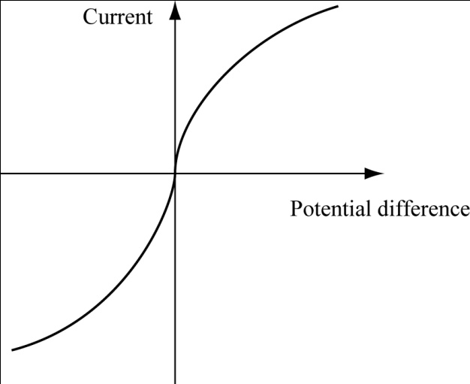
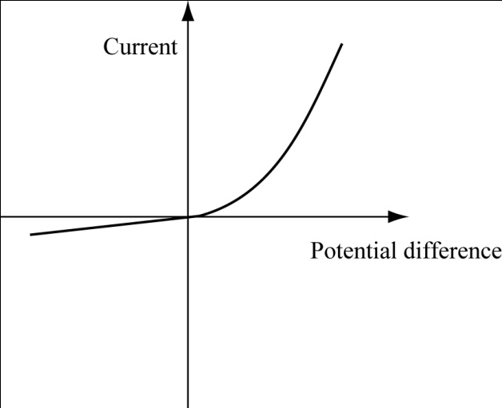
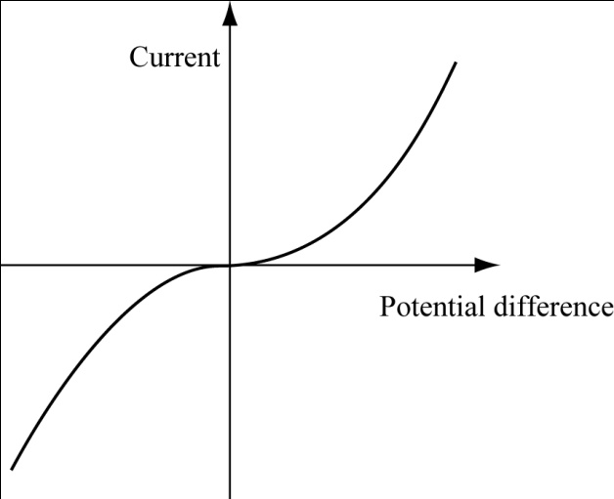
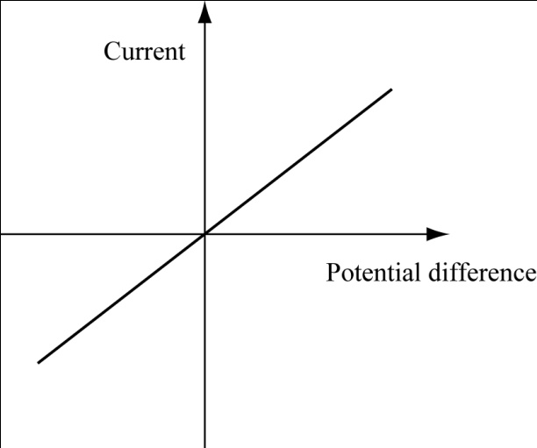
D
C

88. The diagrams show two wires both made from the alloy eureka. Wire 1 has length L, diameter d and resistance R. Wire 2 has length 2L and diameter 2d.
wire 1 wire 2
What is the resistance of wire 2? [1]
A R
B R
C R
D 2 R
89. The graph shows the variation of the resistance of a thermistor with temperature.
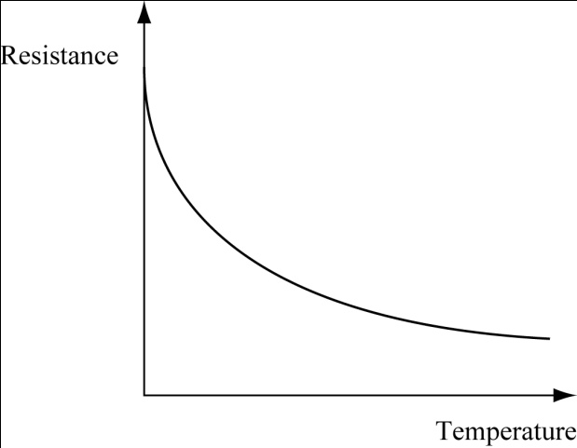
Which conclusion can be made directly from the graph? [1]
A The resistance of the thermistor increases when the current through it increases.
B The resistance of the thermistor increases when the potential difference across it decreases.
C The resistance of the thermistor increases when the temperature of the thermistor decreases.
D The resistance of the thermistor increases when the temperature of the thermistor increases.
90. A student has a metallic conductor and a semiconductor. The temperature of the two materials
is raised.Which line in the table correctly shows the change in their resistance? [1]
Metallic conductor  A  B  C  D | Semiconductor
decreases | decreases
decreases | increases
increases | decreases
increases | increases

91. The graph shows the I–V characteristics of a filament lamp.
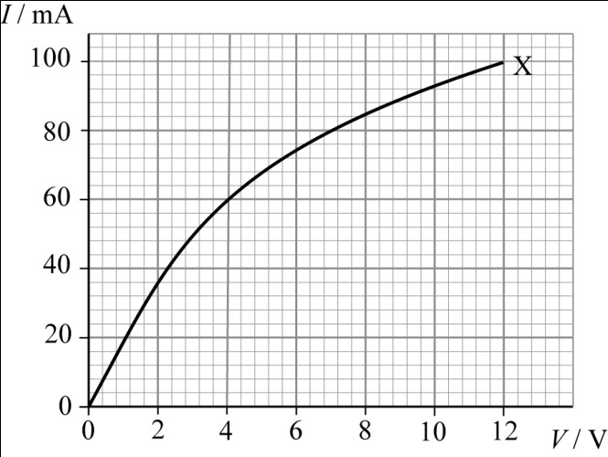
a Does the lamp obey Ohm’s law? Explain your answer. [1]
b Calculate the resistance of the lamp at 4.0 V. [3]
c Describe how the resistance of the lamp depends on the current. [1]
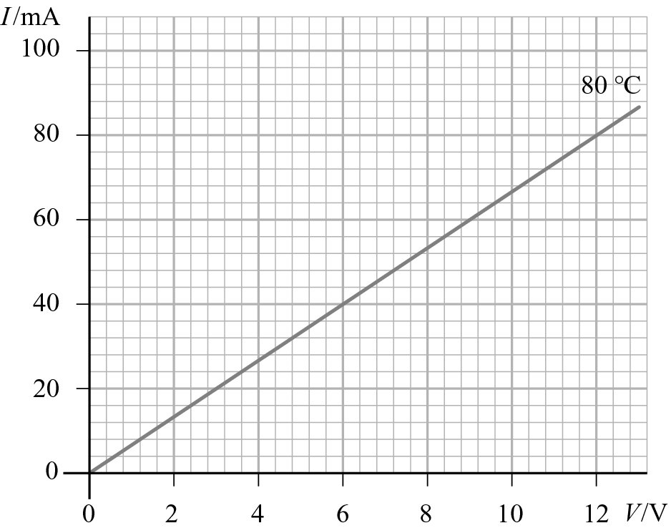
92. A negative temperature coefficient (NTC) thermistor and its connecting leads are coated with a high-resistivity plastic material. The thermistor is placed in a beaker containing hot water. The temperature of the water is kept constant at 80 °C. The I–V characteristic of the thermistor is shown below.

a Calculate the resistance of the thermistor. [2]
b State and explain the change, if any, to the shape of the graph of I against V when the temperature is lowered and maintained at 30 °C. [2]
93. A wire is made of a material of resistivity ρ. Write an equation for the resistance R of a wire
of length L and diameter d. [2]
94. A manganin wire of radius 0.15 mm has a resistance of 5.33 Ω per metre of length.
a Calculate the resistivity of manganin. [4]
b Explain how your answer to a would change if the manganin wire had twice the radius. [2]

95. Which of the following is the basic SI unit for electric charge? [1]
A ampere
B coulomb
C ohm
D volt
96. What are the charge carriers in a solution during electrolysis? [1]
A electrons only
B positive ions only
C negative ions only
D both positive and negative ions
97. There is a current of 0.24 A through a lamp for 40 minutes.
How much charge passes through the lamp? [1]
A 576 C
B 9.6 C
C 0.60 C
D 0.01 C
98. When a resistor is connected across a battery of 2.8 V there is a current of 0.35 A.
What is the resistance of the resistor? [1]
A 8.00 Ω
B 1.02 Ω
C 0.98 Ω
D 0.13 Ω
99. A car headlamp when connected to a 12 V battery converts energy at a rate of 50 W.
How much energy is converted when it is switched on for 5 minutes? [1]
A 2 J
B 120 J
C 300 J
D 150 000 J
100.A current of 2.0 A passes through a component of resistance 24 Ω.
What is the rate of energy transfer? [1]
A 6 W
B 12 W
C 48 W
D 96 W
101. Calculate the charge passing a point in a wire carrying a current of 1.2 A for 3.0 minutes. [2]
102. Calculate the current for a calculator battery delivering a charge of 3.8 × 10⁻³ C in 120 s. [2]
103. A component is connected to a d.c. supply. The supply has negligible internal resistance.
At 6.0 V, the current in the component is 0.023 A. When the p.d. is doubled, the current in the component increases to 0.100 A.
a Calculate the resistance of the component at 6.0 V. [2]
b Does the component obey Ohm’s law? Explain your answer. [2]

104. The diagram shows the I–V characteristics of two components  A and B. | 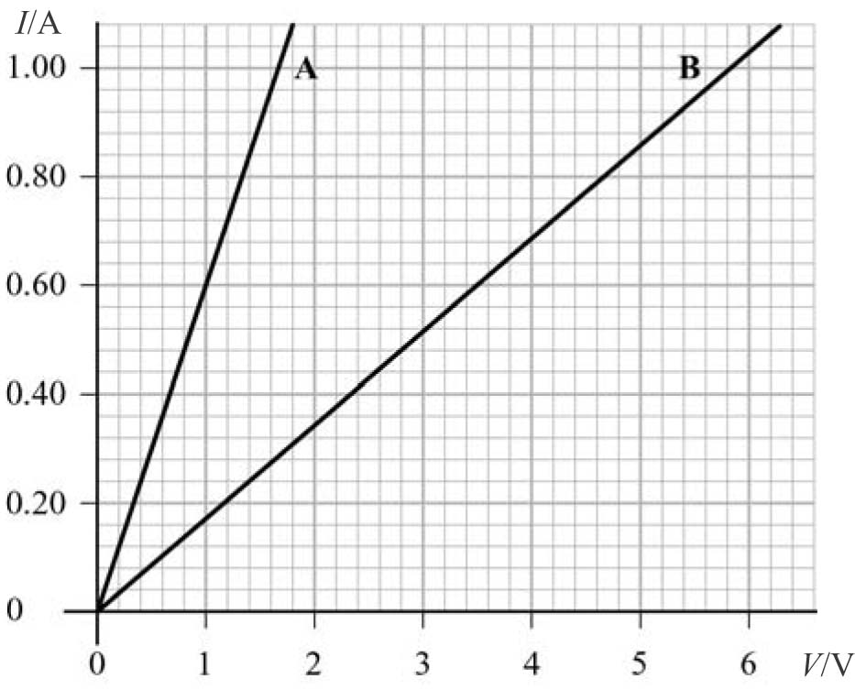
Calculate the resistances of A and B. [2]
105. Calculate the potential difference across a component that transfers 15 J of energy when a charge of 4.2 C flows through it. [2]
106. A 12 V, 36 W lamp is operated for 1 hour (3600 s). Calculate:
a the energy dissipated by the lamp [2]
b the current in the lamp. [2]
107. A solar cell delivers an average current of 80 mA over a 6-hour period. Calculate the total charge that flows from the solar cell. [3]
108. A resistance wire carries a current of 2.0 A. Calculate the number of electrons flowing past a point in the wire per second. [3]
109.18 C to the ground. Calculate:
a the duration of the lightning strike [3]
b the number of electrons transferred to the ground. [2]
110. A 100 Ω resistor can safely dissipate 0.25 W. Calculate the maximum current in the resistor. [3]
111. A filament lamp in a small torch is labelled as ‘1.5 V, 400 mA’. The filament lamp transfers 5.0% of the electrical energy into light and the remainder is dissipated as heat. Calculate:
a the power rating of the lamp [2]
b the power radiated as light [2]
c the resistance of the filament lamp. [2]
112. A cell provides a constant current to a circuit. The diagram shows the graph of current against time.
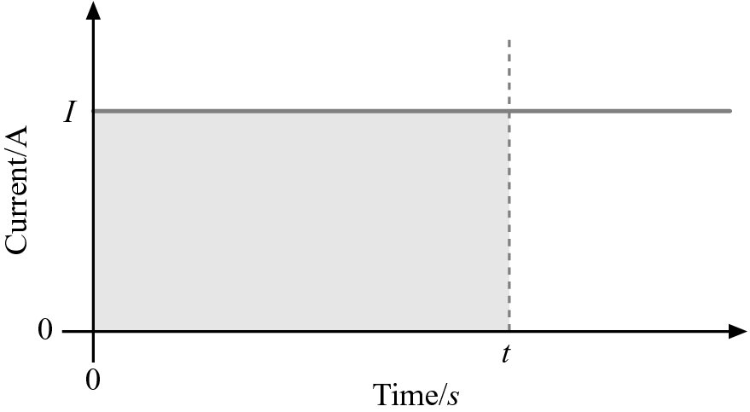
a Calculate the flow of charge Q in a time t when the current is I. [1]
b Justify the statement: ‘the area under a current–time graph is equal to the
charge flow’. [1]
c Given that the information in b is always true for any graph of current against time, estimate the total charge delivered by a cell when the current varies as shown in the graph below. [2]
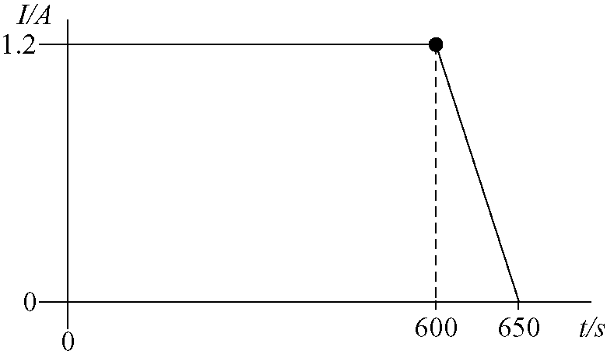
[1]
113.Which of the following could be measured in the same units as force? [1]
A energy ÷ speed
B energy × speed
C power ÷ speed
D power × speed
114. Car P has twice the speed of car Q but car Q has four times the mass of car P.
Which statement is correct? [1]
A Car P has half the kinetic energy of car Q.
B Car P has one quarter of the kinetic energy of car Q.
C Car P has twice the kinetic energy of car Q.
D The two cars have the same kinetic energy.
115. A car travels at constant speed down a hill from P to Q.
Which statement is correct? [1]
A The change in the kinetic energy of the car is equal to the change in its potential energy.
B The change in the kinetic energy of the car is greater than the change in its potential energy.
C There is no change in the kinetic energy of the car.
D There is no change in the potential energy of the car.
116. A box is pushed along a horizontal floor by a horizontal force of 60 N. There is a frictional
force between the box and the floor of 50 N.
What is the gain in kinetic energy of the box when it moves a distance of 4.0 m? [1]
A 40 J
B 200 J
C 240 J
D 440 J
117. What involves the greatest mean power? [1]
A lifting a weight of 300 N at a speed of 20 m s^{–1}
B lifting a weight of 4000 N at a speed of 1 m s^{–1}
C pulling a car with a force of 2 kN at a constant speed of 2 m s^{–1} on a horizontal surface
D pulling a car with a force of 1.5 kN at a constant speed of 5 m s^{–1} on a horizontal surface
118. Which of the following has greater kinetic energy?
- A 10 g meteor hurtling through the Earth’s atmosphere at 5.0 km s⁻¹.
- A 65 kg jogger running at 5.0 m s⁻¹. [3]
119. A water pump lifts 9.0 kg of water through a vertical height of 3.5 m in 1.0 minute. Calculate:
a the gain in gravitational potential energy of the water [2]
b the power of the pump. [2]
120. A ball of mass 800 g is dropped from a height of 5.0 m and rebounds to a height of 3.8 m.
The air resistance is negligible. Calculate:
a the kinetic energy of the ball just before impact [2]
b the initial rebound speed of the ball [3]
c the energy transferred to the ground during the impact. [1]
121. The diagram shows a child on a swing. The mass of the child is 35 kg. The child is raised to
point A and then released. She swings downwards through point B.
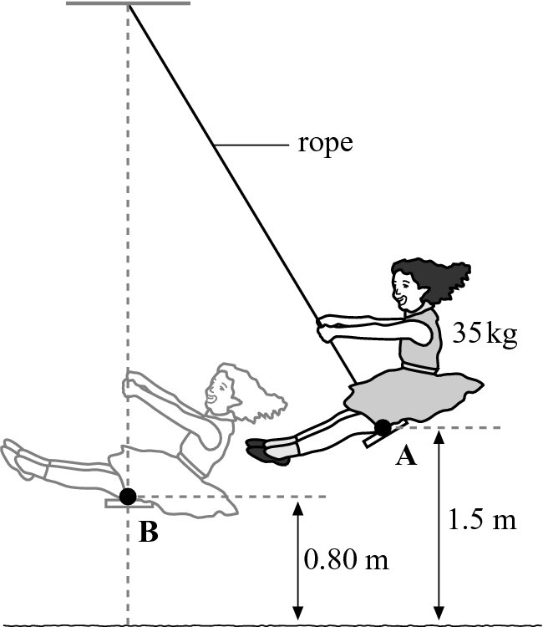
a Calculate the change in gravitational potential energy of the child between A and B. [2]
b Assuming that air resistance is negligible, calculate the speed of the child as she passes through the equilibrium position B. [2]
c The rope stays taut throughout. Explain why the work done by the tension in the rope
is zero. [1]
122. A stunt person slides down a cable that is attached between a tall building and the ground.
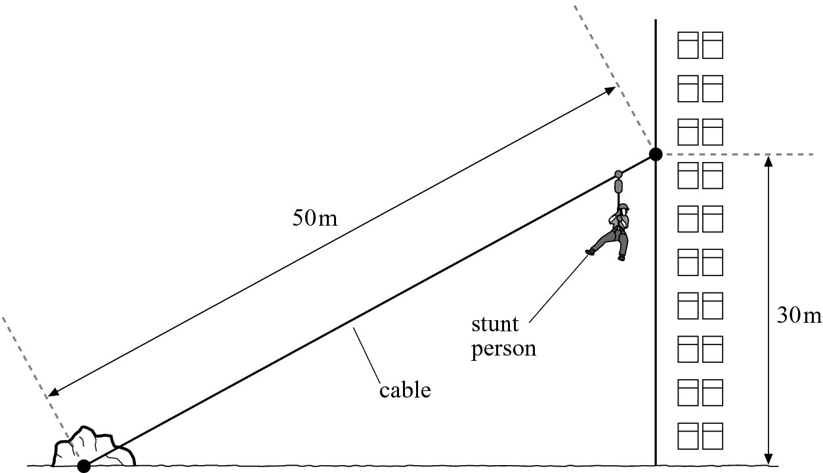
The stunt person has a mass of 85 kg. The speed of the person when reaching the ground
is 20 m s⁻¹. Calculate:
a the change in gravitational potential energy of the person [2]
b the final kinetic energy of the person [2]
c the work done against friction [1]
d the average friction acting on the person. [2]
123. The diagram shows an object of mass m falling towards the surface of the Earth.
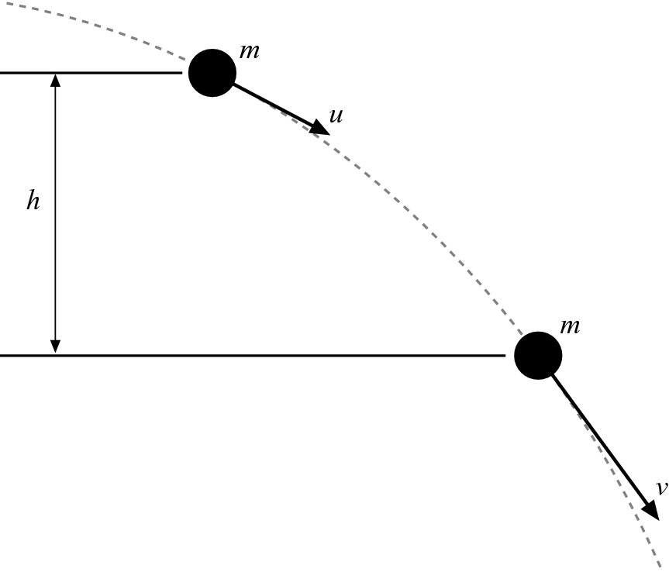
Assuming that there is negligible air resistance and using the principle of conservation of
energy, show that:
v² = u² + 2gh
where u is the initial speed of the object and v is the speed of the object after falling through a vertical height h. [3]
124. A bullet of mass 30 g and travelling at a speed of 200 m s⁻¹ embeds itself in a wooden block. The bullet penetrates a distance of 12 cm into the wood. Using the concepts of work done by a force and kinetic energy, determine the average resistive force acting on the bullet. [3]
125. The diagram shows a 50 kg crate being dragged by a cable up a ramp that makes an angle of
24° with the horizontal.
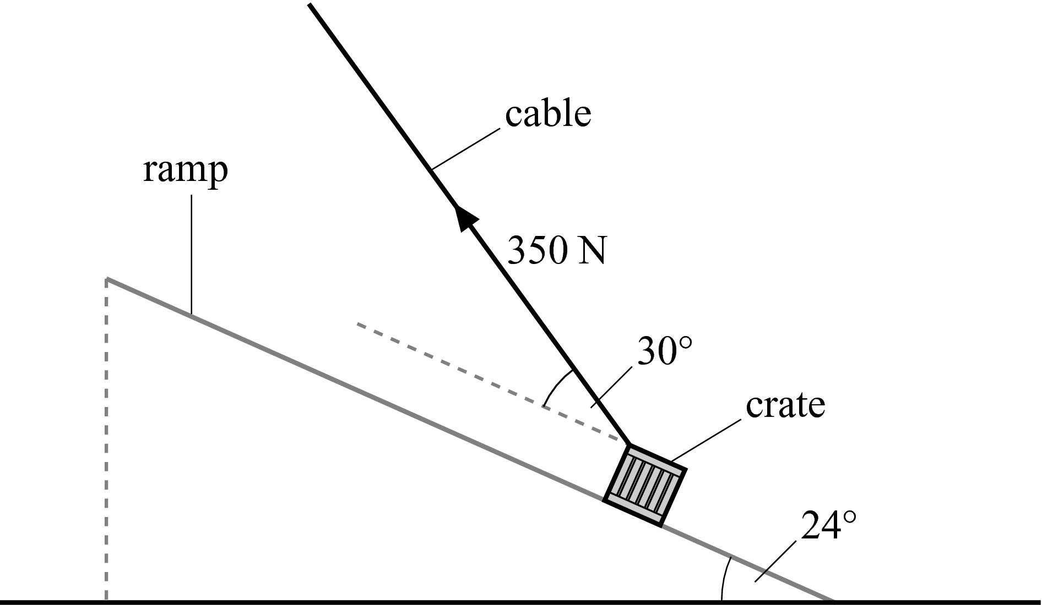
The crate moves up the ramp at a constant speed and travels a total distance of 20 m up the
ramp. Determine the magnitude of the friction between the crate and the surface of the ramp. [6]

